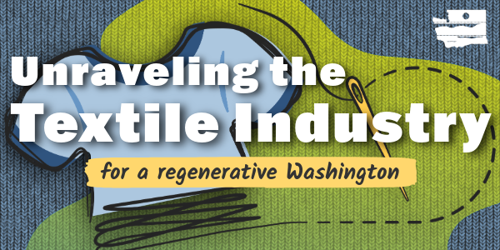
The Washington State Recycling Market Development Center part of the Department of Ecology, dedicated extensive time and collaborative effort to researching, building partnerships, and establishing a trusted network of local, national, and global textile industry leaders. Supported by a collaborated effort through the Textile Co-Design team, this work culminated in a four-part webinar series: Unraveling the Textile Industry for a Regenerative Washington. Through radical collaboration, we level-set, defined, and weaved the global complexities of the textile industry into a regional context. This document provides the summary for Webinar #2: Ripping the Stitch: Business Transformation, May 8th 10am - 12:30pm PST.
Goal: Equip textile businesses with practical insights to transition into or maintain circular business models through real-world examples and peer learning.
Outcomes:  - Understand circular business model elements (product, model, ecosystem)  - Learn from small-to-medium PNW businesses’ real-world experiences  - Identify motivations, challenges, and opportunities in circular practices  - Connect with like-minded businesses during breakout discussions | Key Topics:  - Circular economy business types (upcycling, repair, rental)  - Elements of circular business models  - Peer sharing: motivations, logistics, costs, and market demand

Recycling Market Development Center:
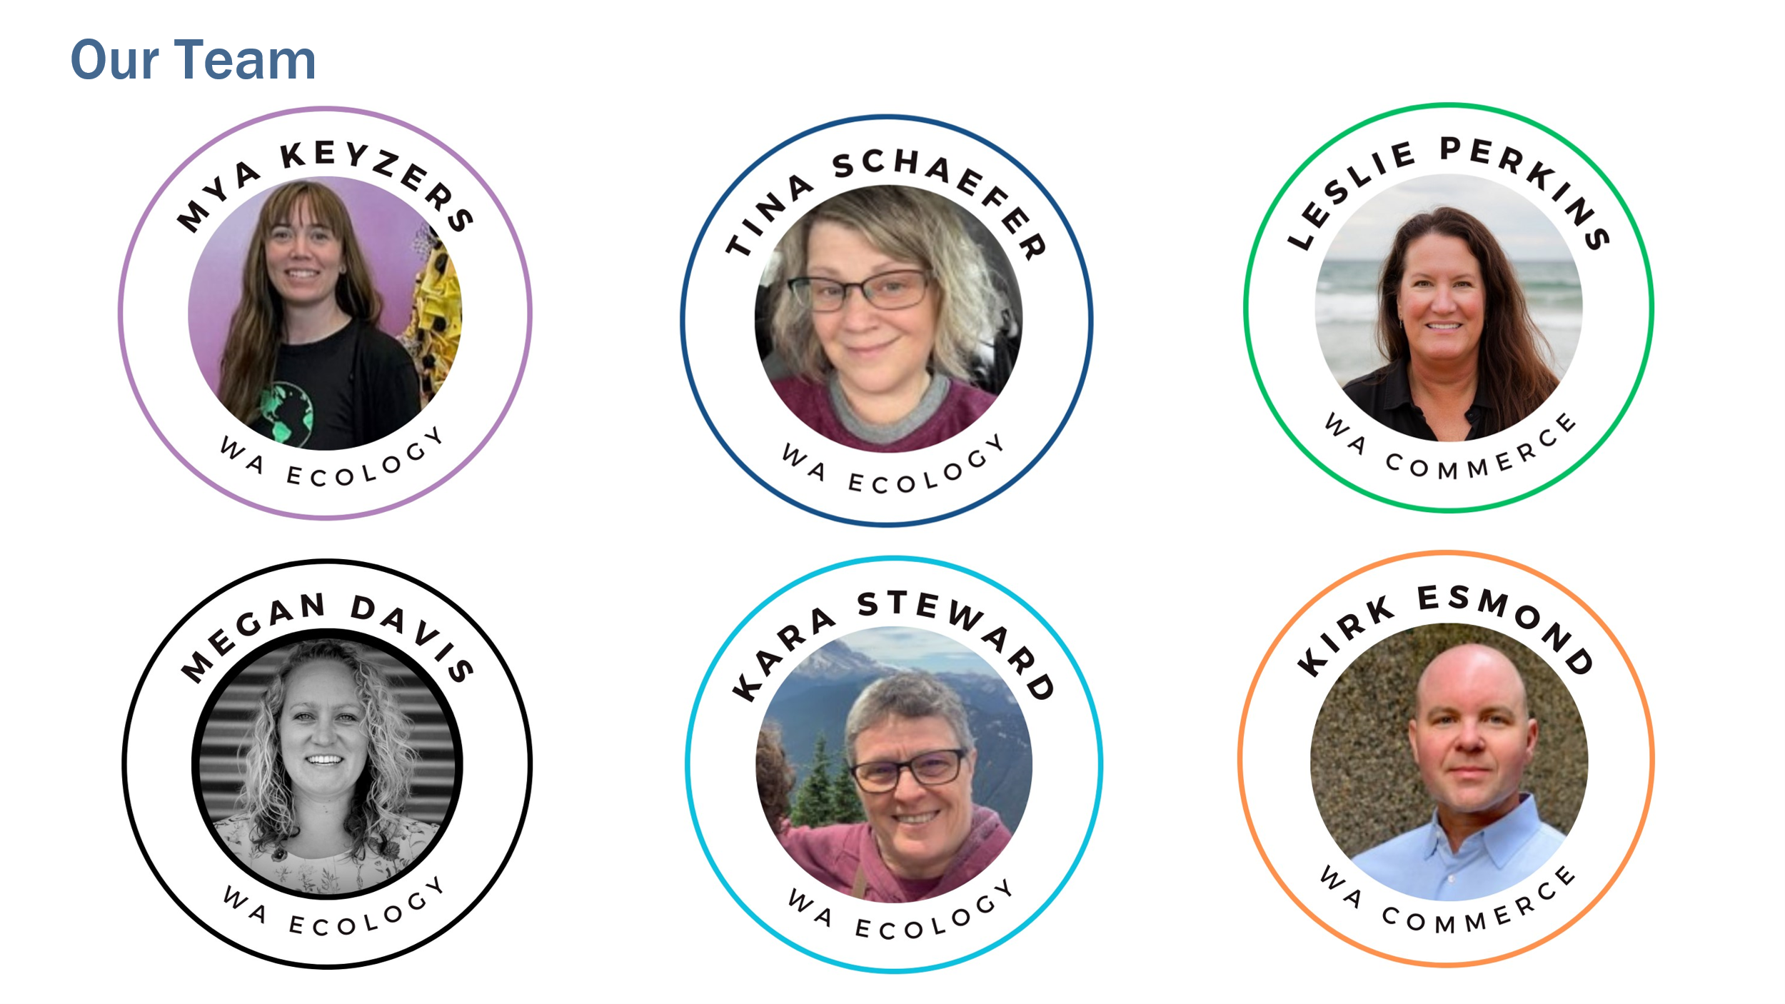
Newsletter

Hosts:
- Timothy Parent fashion advocate for Reforme U | Home
- Behnosh Najafi, Co-Founder, The Sustainable Design Project

Exploring Different Business Models:
- Thrift/Resell/Workforce Development
  - Speaker: Julie Kimball-Bryant
  - Organization: Global Neighborhood
  - Contact: julie@global-neighborhood.org
- Micro-Enterprise/Upcycling
  - Speaker: Lisa Hilbert
  - Organization: Redesign Collective
  - Contact: lisa@redesign-collective.com
- Polyester Textile Recycling
  - Speaker: Zalen Titcomb
  - Organization: Ravel
  - Contact: zahlen@ravelfuture.com
- Circular Business Framework
  - Speaker: Nicole Bassett
  - Organization: Citrus Circular & Renewal Workshop
  - Contact: a.nicole.bassett@gmail.com

Funding & Resources for Circular Businesses:
- Leslie Perkins, Circular Economy Development Manager
  - Organization: Washington Commerce – Office of Economic Development
  - Contact: leslie.perkins@commerce.wa.gov
- Nina Olivier, Circular Economy Program Manager
  - Organization: King County Washington
  - Contact: nolivier@kingcounty.gov
Key Takeaways:
- The goal is to create a circular economy, which requires collective effort from all stakeholders: startups, corporations, government, regulators, nonprofits, and individuals.
- Washington has a strong ecosystem that offers resources and support for circular economy initiatives, despite challenges in federal funding.
- Local and regional opportunities exist for funding, technical assistance, and business planning in textile circularity.
- There’s a need for policies like extended producer responsibility, which prioritizes domestic reuse and closed-loop upcycling of textiles.
- Pre-consumer textile waste is a major contributor to overall textile waste (41 times more than used clothing).
- Refugee communities often have cultural practices around reuse, repair, and repurposing, and these traditions should be included and honored in sustainability conversations.
- Environmental justice and people-centered approaches are crucial in sustainability work.
Other Resources:
- Slide deck for webinar #1 Level Setting
- Slide deck for webinar #2 Business Transformation
- Slide deck for webinar #3 Adopting New Innovations
- Slide deck for webinar #4 Advocacy & Coalition Building.
- Contacts and key takeaways for webinar #1 Level Setting
- Contacts and key takeaways for webinar #3 Adopting New Innovations
- Contacts and key takeaways for webinar #4 Advocacy & Coalition Building.
- Megan Davis megan.davis@ecy.wa.gov
- Mya Keyzers mya.keyzers@ecy.wa.gov

